

**Mobile Applications Development**

**Intent and Splash screen**

**Course Instructor:** Muhammad Ahmed  **Total Marks: 10**

Student Name: Muhammad Haroon

Q1: Implement Intent and Splash screen with following properties:

1. First implement splash screen and Intent.

☺☺☺☺ *Good Luck* ☺☺☺☺

Solution:

**Splash**

**Splash XML:**

<?*xml version*="1.0" *encoding*="utf-8"?>  
<androidx.constraintlayout.widget.ConstraintLayout *xmlns:android*="http://schemas.android.com/apk/res/android"  
 *xmlns:app*="http://schemas.android.com/apk/res-auto"  
 *xmlns:tools*="http://schemas.android.com/tools"  
 *android:layout_width*="match_parent"  
 *android:layout_height*="match_parent"  
 *android:background*="@color/black"  
 *tools:context*=".Splash">  
  
 <ImageView  
 *android:layout_width*="237dp"  
 *android:layout_height*="246dp"  
 *android:src*="@drawable/lgs2"  
 *app:layout_constraintBottom_toBottomOf*="parent"  
 *app:layout_constraintEnd_toEndOf*="parent"  
 *app:layout_constraintStart_toStartOf*="parent"  
 *app:layout_constraintTop_toTopOf*="parent"  
 *app:layout_constraintVertical_bias*="0.412" />  
  
   
  
</androidx.constraintlayout.widget.ConstraintLayout>

**Splash Java Code:**

*package* com.example.lspashsecreen;  
  
*import* androidx.appcompat.app.AppCompatActivity;  
  
*import* android.content.Intent;  
*import* android.os.Bundle;  
*import* android.os.Handler;  
  
*public class* Splash *extends* AppCompatActivity {  
  
 @Override  
 *protected void* onCreate(Bundle savedInstanceState) {  
 *super*.onCreate(savedInstanceState);  
 setContentView(R.layout.*activity_splash*);  
 *new* Handler().postDelayed(*new* Runnable() {  
 @Override  
 *public void* run() {  
 Intent intent = *new* Intent(Splash.*this*,MainActivity.*class*);  
 startActivity(intent);  
  
 }  
 },2000);  
 }  
}

**Splash Design:**

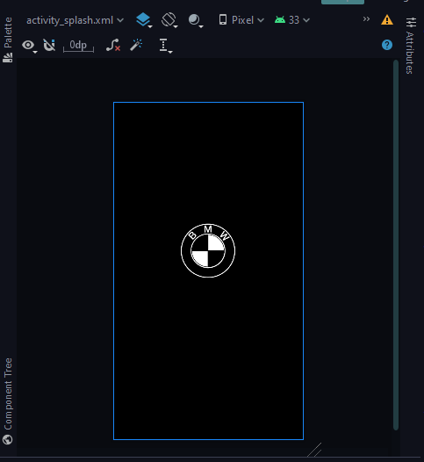

**Main Activity**

**Main Activity Xml:**

**<?*xml version*="1.0" *encoding*="utf-8"?>  
<androidx.constraintlayout.widget.ConstraintLayout *xmlns:android*="http://schemas.android.com/apk/res/android"  
 *xmlns:app*="http://schemas.android.com/apk/res-auto"  
 *xmlns:tools*="http://schemas.android.com/tools"  
 *android:layout_width*="match_parent"  
 *android:layout_height*="match_parent"  
 *android:background*="@drawable/bj1"  
 *tools:context*=".MainActivity">  
  
 <androidx.cardview.widget.CardView  
 *android:layout_width*="233dp"  
 *android:layout_height*="496dp"  
 *android:backgroundTint*="#561D45BF"  
 *app:cardCornerRadius*="25dp"  
 *app:layout_constraintBottom_toBottomOf*="parent"  
 *app:layout_constraintEnd_toEndOf*="parent"  
 *app:layout_constraintHorizontal_bias*="0.5"  
 *app:layout_constraintStart_toStartOf*="parent"  
 *app:layout_constraintTop_toTopOf*="parent"  
 *app:layout_constraintVertical_bias*="0.5" >  
  
 <TextView  
 *android:layout_width*="match_parent"  
 *android:layout_height*="wrap_content"  
 *android:layout_margin*="24dp"  
 *android:text*="Intent and Suplash Secreen is Completed Sucessfully"  
 *android:textColor*="@color/white"  
 *android:textSize*="28dp" />  
 </androidx.cardview.widget.CardView>  
  
</androidx.constraintlayout.widget.ConstraintLayout>**

**Main Activity Java:**

*package* com.example.lspashsecreen;  
  
*import* androidx.appcompat.app.AppCompatActivity;  
  
*import* android.os.Bundle;  
  
*public class* MainActivity *extends* AppCompatActivity {  
  
 @Override  
 *protected void* onCreate(Bundle savedInstanceState) {  
 *super*.onCreate(savedInstanceState);  
 setContentView(R.layout.*activity_main*);  
 }  
}

**Main activity Design:**

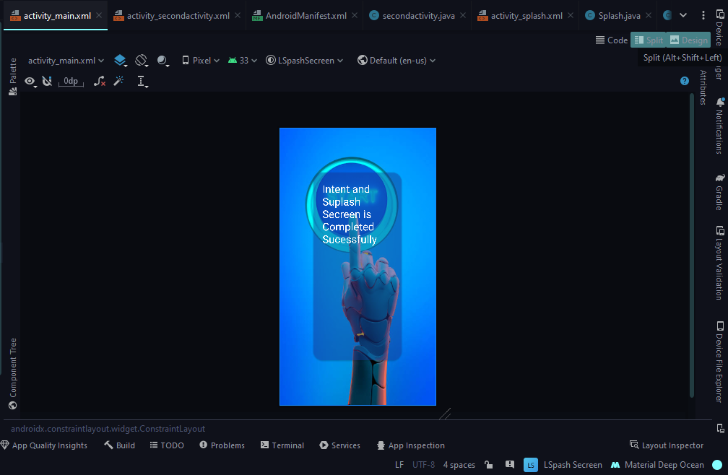

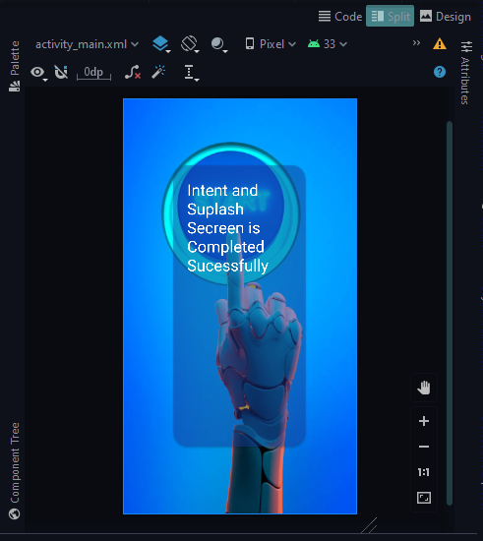

**Main Fest Xml:**

<?*xml version*="1.0" *encoding*="utf-8"?>  
<manifest *xmlns:android*="http://schemas.android.com/apk/res/android"  
 *xmlns:tools*="http://schemas.android.com/tools">  
  
 <application  
 *android:allowBackup*="true"  
 *android:dataExtractionRules*="@xml/data_extraction_rules"  
 *android:fullBackupContent*="@xml/backup_rules"  
 *android:icon*="@mipmap/ic_launcher"  
 *android:label*="@string/app_name"  
 *android:roundIcon*="@mipmap/ic_launcher_round"  
 *android:supportsRtl*="true"  
 *android:theme*="@style/Theme.LSpashSecreen"  
 *tools:targetApi*="31">  
 <activity  
 *android:name*=".secondactivity"  
 *android:exported*="false" />  
 <activity  
 *android:name*=".Splash"  
 *android:exported*="true">  
 <intent-filter>  
 <action *android:name*="android.intent.action.MAIN" />  
  
 <category *android:name*="android.intent.category.LAUNCHER" />  
 </intent-filter>  
 </activity>  
 <activity  
 *android:name*=".MainActivity"  
 *android:exported*="true"></activity>  
 </application>

**<<<<<<<<<<<<<<<<<<<<<<<<<<<<<<The End>>>>>>>>>>>>>>>>>>>>>>>>>>>>>**